Treasure Hunt User’s Manual
- Introduction
  - Mothboard …………………..…………………………………………1

  - Light …………………………………………………………………2

  - Operating Button……………………………………………………...2
- Statistics Mode
  - How to Enter………………………………………………………………2

  - Clear Today’s Value……………………...…………………………3

  - Check Record …………………………………………………………3

  - Clear Record…………………….………………………………………3

  - Check Payout Record ……………………….…………………….…..3

  - Clear Payout Record……………………………………………….…..4

  - Exit ……………………………………………………………………..4
3. Setting Mode
3-1. How to Enter ……………………………………….………………...4

3-2. Coin Set-up ……………………………………………………………..5

3-3. Time Set-up…………………………………………….…….……..5

3-4. Payout Rate Set-up……………………………………………..……..6

3-5. X Axle Coordinate Set-up ……………………………….……...…..7

3-6. Y Axle Coordinate Set-up……………………………………….……..8
3-7. Positioner Set-up…… ………………….………..……….……...8
3-8. Displacement Set-up …………………………..….……….…..….8
3-9. Horizontal Set-up …… ………….………… ……..…..….……..9
3-10. Exit……………………..………… ………..………...……..9

- Introduction
  - Machine should be placed on horizental ground; no tilting or shaking.
  - Fixed machine bottom to avoid moving.
  - Close gift doors.
(Left door is outside of left outter track, right door is inside of right inner track.)
  - Motherboard
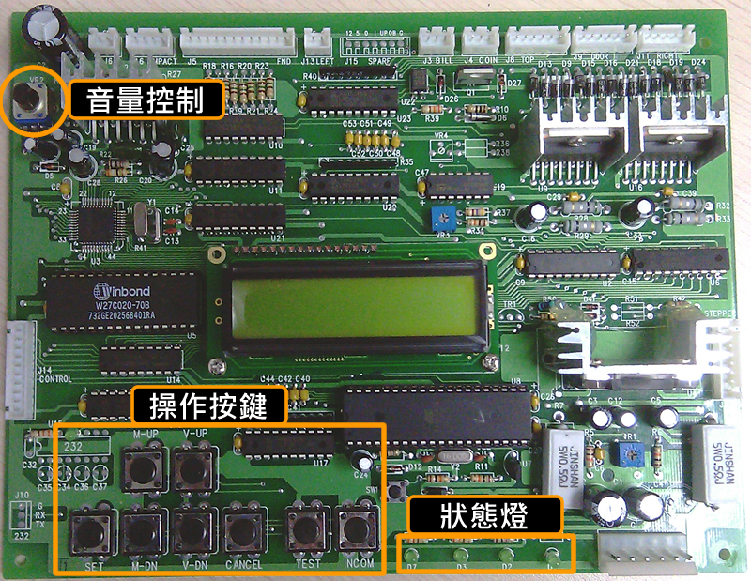
volumecontrolol
Handle button
Estate lamp

  - Light
- D7 will be glittering every half second.
- D3 is 24V indicator.
- D2 is 12V indicator.
- D1 is 5V indicator.
  - Operation Button
- Push button for 3 seconds.
- Changing menu by pushing 【M-UP】及【M-DN】.
- 【V-UP】&【V-DN】to adust value.
- 【CANCEL】Exit
- 【TEST】Equal to 1 coin, but no record.
- 【INCOM】to save change.
- Statistics Mode
2-1. How to Enter
LCD on the motherboard will be show as below when start:


Push【INCOM】to statistics mode as below:

TODAY means today’s value, TOTAL means total value.
2-2. Clear today’s vlue
Hold 【CANCEL】, then push 【INCOM】. It can clear today’s value, can’t clear total value.
2-3. Check record
Push 【V-UP】, LCD will show Y1~Y6 record.
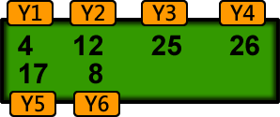
2-4. Clear record
Hold【CANCEL】，push【M-DN】. It can clear record.
2-5. Check Payout Record
Push 【V-DN】，LCD will show Y1~Y6 Payout record.
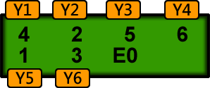
If monitor show as above, Ex（x meansany number） means it not reach set-up Credit value （formula been disturbed）but gift has been payout。If the gift payout is been setting as 20 times，the gift will not be payout uless it reach 20 times. E1 will be show if door open by force and within 1~19times。
2-6. Clear Payout Record
Hold【CANCEL】，then push【V-DN】 。
2-7. Exit
Push【CANCEL】to exit。
- Setting Mode
3-1. How to enter
Push button for 2~3 seconds to enter, if LCD show as below.
Push【SET】 to enter next action.
Note：You can’t enter setting mode if you still have credit.
3-2. Coin Set-up
This set-up is to reflect the credit for coin inserted.

- Adjust Value：Push 【V-UP】to increase，【V-DN】to decrease.
- Predetermined value: 1 COIN
- Adjust range: 1~10
- Push 【INCOM】 to save ( when S showed on right button, it means saved.)
3-3. Time Set-up
During play, LED on the panel will show how many seconds has been play. The machine will be automatically shut down if you donot push UP button within programmed request seconds.

- Adjust Value：Push【V-UP】to increase，【V-DN】to decrease。
- Each Game：20 Seconds
- Predetermined Value: 20 seconds.
- Adjust range 15~40 seconds。
- Push【INCOM】to save ( when S showed on right button, it means saved.)
3-4. Payout Rate Set-up
Y1~Y6 means horizental rows. When CREDITS reach programmed quantity, formula will not interfere with player. However it don’t means player will win; it depends on player’s accuracy. （n）means how many times been play, programmed value will be deduct after gift been payout and keep accumulate.

- Adjust Value：Push【V-UP】to increase，【V-DN】to decrease。
- Adjust Y1~Y6：Push【M-UP】【M-DN】to switch.
- Adjust Value：Y1=20、Y2=30、Y3=40、Y4=30、Y5=20、Y6=10
- Programmed range 1~1000 CREDITS。
- Push 【INCOM】 to save ( when S showed on right button, it means saved.)
3-5. X Axle Coordinate Set-up
Below is X1 & X4 coordinated postion.

- Adjust Value：Push【V-UP】to increase，【V-DN】to decrease。
- Push【M-UP】【M-DN】to switch X1 & X4。
- Predetermined Value：X1=50、X4=3000 。
- Push 【INCOM】 to save ( when S showed on right button, it means saved.)
- Push【TEST】，motor will back to left side, then move to the right. Moving distance is programmed time length.

3-6. Y Axle Coordinate Set-up
Please install acyrlic door properly before set-up Y1~Y6.

- Adjust Value：Push【V-UP】to increase，【V-DN】to decrease。
- Push【M-UP】【M-DN】to switch Y1~Y6。
- Push 【INCOM】 to save ( when S showed on right button, it means saved.)
- Push【TEST】，motor will be in position; move joystick. Please make sure joystick in position and save 。
3-7. Positioner Set-up
This is testing if X1 & X4 position accurate.

- Push【M-UP】【M-DN】to switch COL & COL4。
- Push【TEST】，machine will e tested from Y1 to Y6 position。
3-8. Displacement Set-up
This is interference range setting. Formula will use payout ratio to determinate if interference needed or not when player release UP button.

- Adjust Value：Push【V-UP】to increase，【V-DN】to decrease。
- Push【M-UP】【M-DN】to switch Top & Bottom。
- Push 【INCOM】 to save ( when S showed on right button, it means saved.)
3-9. Horizontal Set-up
This is horizental & vertical motor testing.
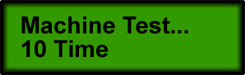
- Push【TEST】，horizental motor will move from left to right，vertical motor will move from bottom to top.
3-10. Exit
- Hold 【SET】for 2 ~3 seconds to exit.

